**THE UNITED REPUBLIC OF TANZANIA**

**PRESIDENT’S OFFICE**

**REGIONAL ADMINISTRATION AND LOCAL GOVERNMENT**

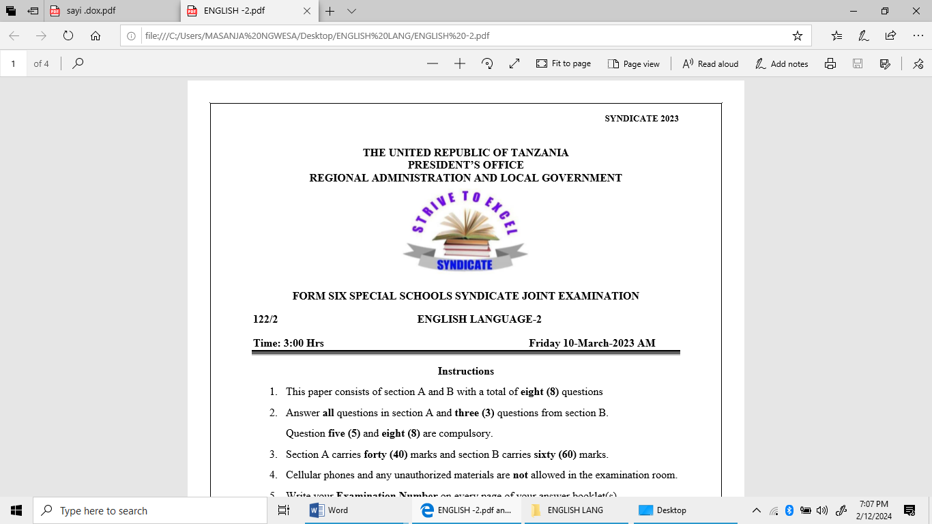

**FORM SIX SPECIAL SCHOOLS SYNDICATE JOINT EXAMINATION**

**122/2 ENGLISH LANGUAGE 2**

**MARKING GUIDE**

1. A candidate is required to draw comparison/Similarities between written and oral literature

Oral literature despite its medium being handed down by word of mouth shares some similarities with written literature such as:

1. Purpose; oral literature educates or entertains as much as written literature.
2. Figures of speech or figurative language; both genres employ an array of nonliteral words such as metaphors.
3. Both are by far imaginative with the use of unreal events, characters and settings
4. They are both forms of communication requiring the sender (i.e. writer or story teller) and the receiver or audience (i.e. listeners or readers).
5. They are all directed towards a society consequently should reflect such society.

* And any other relevant similarity should be awarded marks.

**@ 2 marks = 10 marks**

1. A candidate is required to give any relevant definition/ or related to ones given below.
   1. A cloth or other material that can be raised or lowered at the front of the stage so as to mark the beginning or end of an act or scene.
   2. Aside is when a character expresses to the audience his or her thought or intention in a short speech which, by convention, is inaudible to the other characters on the stage.
   3. A set of clothes worn by an actor or performer for a role.
   4. A trial performance of a play for later public performance.
   5. Stage directions are the instructions a playwright gives to the director and the actors about how a play should be staged. They provide information about setting, the characters’ actions and movements and the style of acting.
   6. Soliloquy in drama denotes the convention by which a character, alone on the stage, utters his or her thoughts aloud.
   7. The main drama technique. Involves the conversation among characters.
   8. The term is broadly applied to literary, and especially to dramatic, representations of serious actions which eventuate in a disastrous conclusion for the protagonist.
   9. A section/speech at the end of a play serving as a comment on or conclusion to what has happened.
   10. A heroine is the play’s main female character (female protagonist)

**@ 1 mark = 10 marks**

1. A candidate is required to give any five stylistic features of a memorandum (memo). The following below serves as a guide
2. Brief and direct
3. Has a heading
4. Has a part showing the receiver of a memo
5. Has a part showing the sender of a memo
6. Date of the memo
7. Body of the memo (details of the message)
8. All writings begin from the margin line
9. Operates within organization

**@ 2 marks = 10 marks**

1. A candidate is required to answer the questions as asked.
2. A candidate may name one of the following with the reason – **2 marks**

* Lyric
* Descriptive
* Modern

1. The poem has irregular rhyme scheme with exception to the third stanza. The pattern is indicated as follows. **2 Marks**

*ABCDE FGFEB HBBII JBJKELJ*

1. A persona is any person in a society who observes the dentist behaviors. This can be seen as he narrates/describes the dentist and his services as it is shown in stanza 3. **2 Marks**
2. A candidate may comment on any two poetic devices from the poem - @1 mark = **2 marks**

Example,

* Consonance

*Decaying teeth, aching teeth, strong teeth*

* Rhyme – third stanza *HBBII*
* Hyperbole

*Making heaps and heaps of teeth*

1. A candidate is required to give any two relevant messages from the poem. @1 mark = **2 marks**
2. A candidate should clearly analyses imagery portrayed in the four poems of his choice. – **20 Marks**

* Introduction – 2 marks
  + Defining imagery – 1 Mark
  + Introducing the poems, he/she going to use – 1 mark
* Main Body
  + 16 Points, 4 from each poem. – @ 1 mark = 16 Marks
* Any relevant conclusion – 2 marks

1. A candidate should justify by showing relevance of any four poems of his/her choice. – **20 Marks**

* Introduction – 2 marks
  + Defining Poetry/Poem/Relevance – 1 Mark
  + Introducing the poems, he/she going to use – 1 mark
* Main Body
  + 16 Points, 4 from each poem. – @ 1 mark = 16 Marks
* Any relevant conclusion – 2 marks

1. A candidate is required to show various malpractices done by leaders which leads to poverty. i.e Embezzlement, corruption etc.… **20 Marks**

* Introduction – 2 marks
  + Defining key term – 1 Mark
  + Introducing the Novels, he/she going to use – 1 mark
* Main Body
  + 8 Points, 4 from each Novel. – @ 2 marks = 16 Marks
* Any relevant conclusion – 2 marks

1. A candidate is required to show problems and their solutions as they have been revealed in 2 Plays. **20 Marks**

* Introduction – 2 marks
  + Defining key term – 1 Mark
  + Introducing the Plays, he/she going to use – 1 mark
* Main Body
  + 8 Points, 4 from each Play. – @ 2 marks = 16 Marks
* Any relevant conclusion – 2 marks